|  |  |  |  |  |  |  |  |  |  |  |  |  |  |
| --- | --- | --- | --- | --- | --- | --- | --- | --- | --- | --- | --- | --- | --- |
| 1 | Name of Student: | S | H | E | E | T | A | L |  | L | A | M | A |
| N | I |  |  |  |  |  |  |  |  |  |  |
| 2 | Name of  Student: | P | A | V | A | N |  | G |  | N | E | T | R |
|  |  | A | K | A | R |  |  |  |  |  |  |  |  |
| A | Name of Student: | K | A | R | T | I | K |  | M |  | M | A | L |
| A | G | A | N | A | V | A | R |  |  |  |  |
| 4 | Name of Student: | A | F | A | A | Q | A | H | A | M | E | D |  |
| J | A | M | A | D | A | R |  |  |  |  |  |
|  | | | | | | | | | | | |
| USN: | | | | | | | | | | | |
| 0 | 1 | F | E | 2 | 0 | B | E | C | 4 | 0 | 1 |
| USN: | | | | | | | | | | | |
| 0 | 1 | F | E | 2 | 1 | B | E | C | 4 | 0 | 2 |
| USN: | | | | | | | | | | | |
| 0 | 1 | F | E | 2 | 1 | B | E | C | 4 | 0 | 3 |
| U | S |  |  |  |  |  |  |  |  |  |  |
| 0 | 1 | F | E | 2 | 1 | B | E | C | 4 | 0 | 9 |

Kaggle : DEEP LEARNING

Project Title: **LICENSE PLATE RECOGNITION SYSTEM**

Problem statement: TO RECOGNIZE LICENCE PLATE NUMBER

Summary:

Type of problem: PREDICTION

Type of Machine Learning algorithm: UNSUPERVISED

Value to be predicted: This project aims to understand the underlying semantics of the text sentence using natural processing techniques to predict License plate number from an image using open-cv tool

Number of features with appropriate labels:

Model used for prediction: CNN model

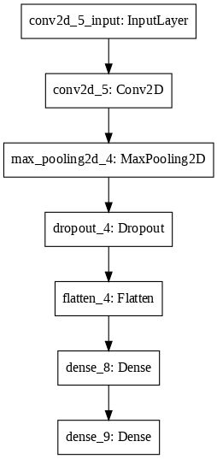 CNN MODEL ARCHITECTURE

Model Summary:

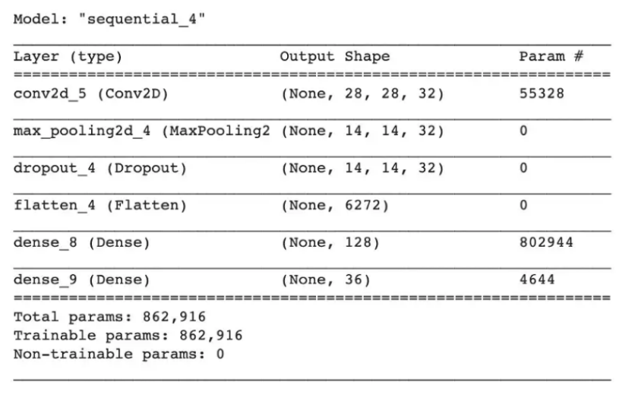

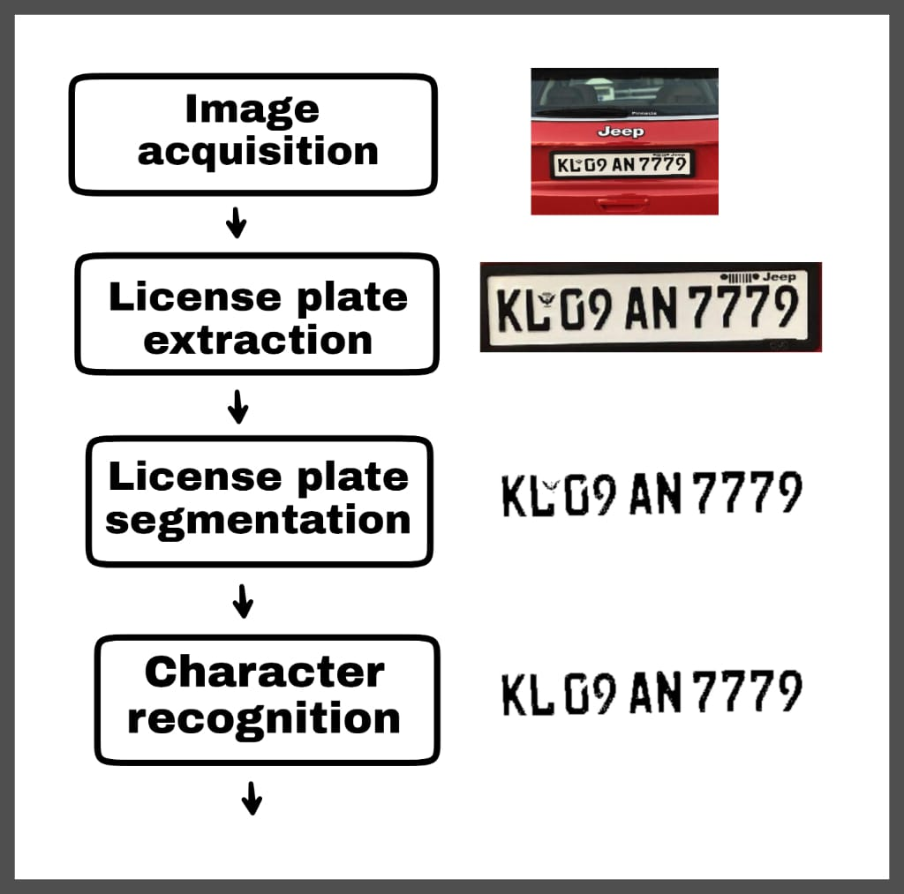

Flow Chart:

Results and Discussion:

Input Data and Expected Output:

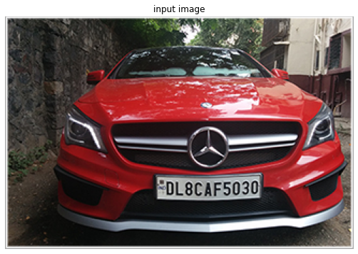 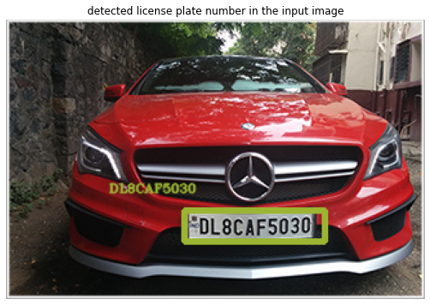

Tools/Programming used: JUPYTER COLAB

Accuracy Achieved:



Visualization of results:

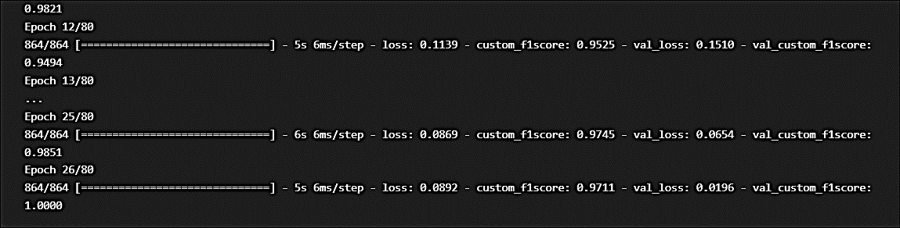

PLOT FOR LOSS PLOT FOR ACCURACY

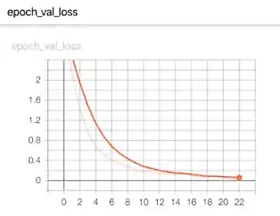 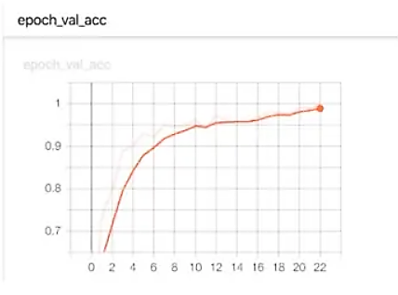

Challenges faced to address the problem:

* These kinds of results obtained from machine learning models is due to the fact that the available data that is being used for training the model is not generalizable enough The characters may be unsorted but don’t worry, the last few lines of the code take care of that. It sorts the character according to the position of their bounding rectangle from the left boundary of the plate. this project is useful for some of you aspiring to do projects on OCR, image processing, Machine Learning, IoT.

Online Link of the project:

[1] Farheen Ali; Himanshu Rathor; Wasim Akram; License Plate Recognition System Published in: 2021 International Conference on Advance Computing and Innovative Technologies in Engineering (ICACITE)

CONCLUSION

we have proposed and implemented a Deep Learning approach using Keras library for CNN model for predicting License plate recognition based on the input Image. This approach yielded the optimal results than all the base machine models.